I-75 / Fruitville Road Interchange

Fruitville Road from Honore Avenue to east of Coburn Road and reconstruction of the I-75 / Fruitville Road Interchange (including ramps)
FPID: 420613-2

Description
The Florida Department of Transportation (FDOT), along with Sarasota County, has iden- tified the need to make improvements to the I-75 / Fruitville Road (SR 780) interchange to improve highway operations, safety, and regional mobility.

This design project includes reconstruction of the interchange at Fruitville Road in Sara- sota County. The Department will rebuild the interchange from the existing partial clover- leaf design to a diverging diamond interchange (DDI). The DDI shifts eastbound traffic
to the left to allow for improved access to northbound I-75 and shifts westbound traffic to the left to allow for improved access to southbound I-75. This approach reduces the number of phases for the signals and improves delay times. A similar type of interchange has recently been constructed and is now in operation at I-75 / University Parkway, which is the next interchange north of this project.

The project will widen about 2 miles of I-75, from Palmer Boulevard to north of Fruitville Road, to a six-lane highway with three through lanes per direction and will replace the existing bridges over Fruitville Road. The project also includes widening of about 1.6 miles of Fruitville Road from Honore Avenue to east of Coburn Road.

A future ultimate I-75 design project will widen the interstate from interim six lanes to ten lanes. The project includes two express lanes and three general use lanes in each direc- tion within the project limits. Ultimate improvements are planned to extend acceptable level of service for I-75 well beyond 2050.

Contact Information:

Ryan Weeks
FDOT Project Manager 863-519-2837
ryan.weeks@dot.state.fl.us

I-75 / Fruitville Road Interchange

Fruitville Road from Honore Avenue to east of Coburn Road and reconstruction of the I-75 / Fruitville Road Interchange (including ramps)
FPID: 420613-2

Description
The Florida Department of Transportation (FDOT), along with Sarasota County, has iden- tified the need to make improvements to the I-75 / Fruitville Road (SR 780) interchange to improve highway operations, safety, and regional mobility.

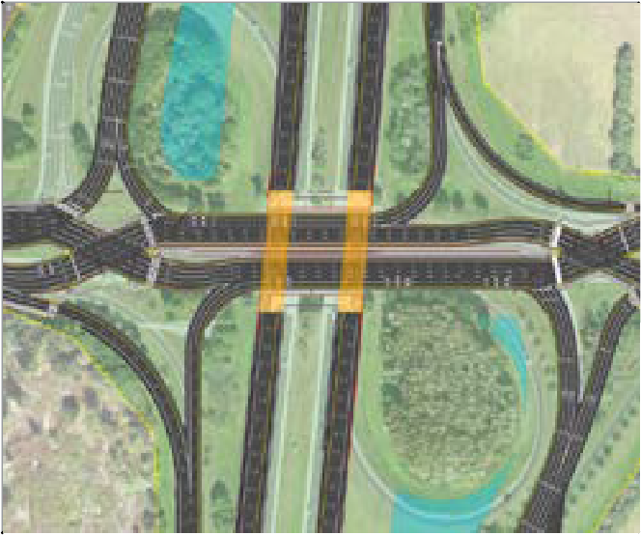This design project includes reconstruction of the interchange at Fruitville Road in Sara- sota County. The Department will rebuild the interchange from the existing partial clover- leaf design to a diverging diamond interchange (DDI). The DDI shifts eastbound traffic
to the left to allow for improved access to northbound I-75 and shifts westbound traffic to the left to allow for improved access to southbound I-75. This approach reduces the number of phases for the signals and improves delay times. A similar type of interchange has recently been constructed and is now in operation at I-75 / University Parkway, which is the next interchange north of this project.

The project will widen about 2 miles of I-75, from Palmer Boulevard to north of Fruitville Road, to a six-lane highway with three through lanes per direction and will replace the existing bridges over Fruitville Road. The project also includes widening of about 1.6 miles of Fruitville Road from Honore Avenue to east of Coburn Road.

A future ultimate I-75 design project will widen the interstate from interim six lanes to ten lanes. The project includes two express lanes and three general use lanes in each direc- tion within the project limits. Ultimate improvements are planned to extend acceptable level of service for I-75 well beyond 2050.

Contact Information:

Ryan Weeks
FDOT Project Manager 863-519-2837
ryan.weeks@dot.state.fl.us

Ryan Weeks
FDOT Project Manager 801 N Broadway Avenue Bartow, FL 33830

Ryan Weeks
FDOT Project Manager 801 N Broadway Avenue Bartow, FL 33830

